Divide and Conquer

Divide and conquer approach divides the bigger problem into smaller subproblems, and the solution to the original large problem is achieved by combining the solutions to the smaller subproblems.

**General Strategy for Divide and Conquer**

Divide and conquer algorithm operates in three stages:

Divide: Divide the problem recursively into smaller subproblems.

Solve: Subproblems are solved independently.

Combine: Combine subproblem solutions in order to deduce the answer to the original large problem.

Because subproblems are identical to the main problem but have smaller parameters, they can be readily solved using recursion. When a subproblem is reduced to its lowest feasible size, it is solved, and the results are recursively integrated to produce a solution to the original larger problem.

Divide and conquer is a top-down, multi-branched recursive method. Each branch represents a subproblem and calls itself with a smaller argument. Understanding and developing divide and conquer algorithms requires expertise and sound reasoning.

The divide and conquer approach is depicted graphically in following figure. Subproblems may not be exactly n/2 in size.

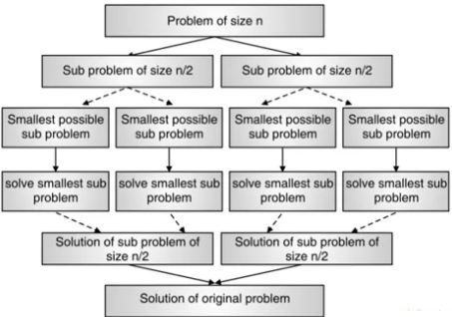

**Applications of Divide and Conquer Approach**

Many computer science problems are effectively solved using divide and conquer. Few of them are listed here:

Finding an exponential number

Multiplying large integers

Multiplying matrices (Strassen’s algorithm)

Sorting data

Quicksort

Merge sort

Searching for an element from the list (Binary search)

Discrete Fourier Transform.

Closest pair problem

Max-min problem

